Chip back potential is the level which bulk silicon is maintained by on-chip connection, or it is the level to which the chip back must be connected when specifically stated below. If no potential is given the chip back should be isolated.

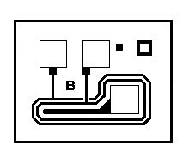
.022”
.019”
MASK
REF
D
S
G

Top Material: Al
Backside Material: Au
Bond Pad Size: .0037” X .0037”
Backside Potential:
Mask Ref: B

APPROVED BY: DK DIE SIZE .019” X .022” DATE: 12/22/16
MFG: SILICONIX THICKNESS .012” P/N: SD210
DG 10.1.2

Rev B, 7/19/02

